LORETO GIRLS 2025 PREDICTION


(EXPECTED KCSE EXAM)
NAME……………………………………………………………………………………….
SCHOOL………………………………………….. INDEX NO………………………….
SIGN………………………………………………...

451/ 1
COMPUTER STUDIES
PAPER 1
(THEORY)
TIME: 2½ HOURS

INSTRUCTIONS TO CANDIDATES:
- Write your name and Admission number in the spaces provided above.
- This paper consists of TWO sections A and B.
- Answer ALL the questions in section A.
- Answer question 16 and any other THREE questions from section B.
- All answer should be written in the spaces provided

SECTION | QUESTIONS | CANDIDATE’S  SCORE
A
B | 16
 | 17
 | 18
 | 19
 | 20
TOTAL

SECTION A (40 MKS)
Answer All the questions in this section in the spaces provided
- Mention any TWO reasons why command-based operating systems are not common in today’s business computer systems. (2mks)
…………………………………………………………………………………………………………
…………………………………………………………………………………………………………
…………………………………………………………………………………………………………

- (a) Name the type of scanner used to capture data from the following document format below (1mk) 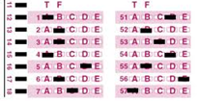
…………………………………………………………………………………………………………

(b) Mention any TWO features that are considered before buying a main memory module. (2mks)
…………………………………………………………………………………………………………
…………………………………………………………………………………………………………
…………………………………………………………………………………………………………

- Briefly describe how the following data security measures function (3mks)
  - Audit trail :……………………………………………………………………………….……
……………………………………………...……………………………………………………………
  - Log files: …………………………………………………………………………………....…………………….
…………………………………………………………………………………………………………...
  - Fire walls : …………………………………………………………………………………………………………
…………………………………………………………………………………………………………..

- (a) Explain the following (2 mks)
i. Search engine – ………………………………………………………………………………………
………………………………………………………………………………………………………….
ii. Web browser – ………………………………………………………………………………………
…………………………………………………………………………………………………………..

(b) The diagram below shows an e-mail extract.
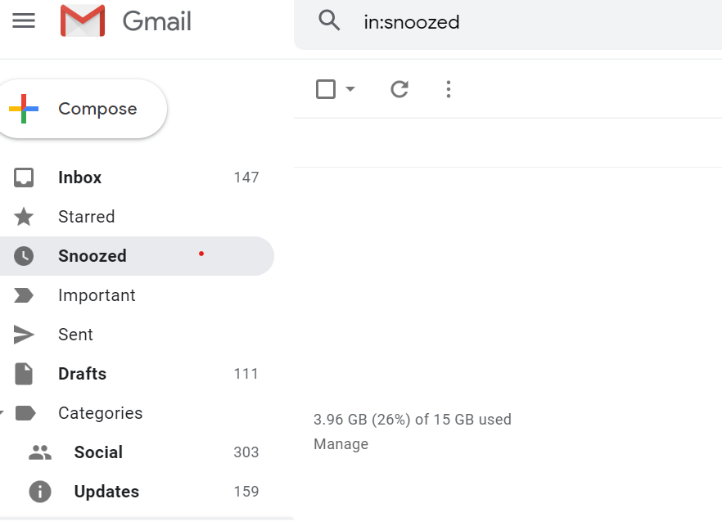

What is purpose of the following folders? (2 mks)
a) Inbox………………………………………………………………………………………………
…………………………………………………………………………………………………………
b) Drafts………………………………………………………………………………………………
…………………………………………………………………………………………………..………

- Describe two types of errors that may be detected during program testing (2mks)
…………………………………………………………………………………………………………
…………………………………………………………………………………………………………
…………………………………………………………………………………………………………
…………………………………………………………………………………………………………

- Perform the following binary operation (2 mks)
11001 + 1101 – 1101

- State two possible causes of fire outbreak in a computer laboratory. (2mks)
…………………………………………………………………………………………………………
…………………………………………………………………………………………………………
…………………………………………………………………………………………………………

- a) What do you understand by the term ‘soft system’ in a system development using an example? (3mks)
…………………………………………………………………………………………………………
…………………………………………………………………………………………………………
…………………………………………………………………………………………………………
…………………………………………………………………………………………………………

b) State two tools that a system analyst may use to design a system (2 mks)
…………………………………………………………………………………………………………
…………………………………………………………………………………………………………

c) List down any four characteristics of a system (4 Mks)
…………………………………………………………………………………………………………
…………………………………………………………………………………………………………
…………………………………………………………………………………………………………
…………………………………………………………………………………………………………
…………………………………………………………………………………………………………
…………………………………………………………………………………………………………
…………………………………………………………………………………………………………

- State three reasons why users may resist the introduction of information and communication Technology (ICT) to their place of work (3mks)
…………………………………………………………………………………………………………
…………………………………………………………………………………………………………
…………………………………………………………………………………………………………
…………………………………………………………………………………………………………
…………………………………………………………………………………………………………

- State three ways in which horticultural farmers can benefit from the use of information and communication technology (3 mks)
…………………………………………………………………………………………………………
…………………………………………………………………………………………………………
…………………………………………………………………………………………………………
…………………………………………………………………………………………………………

- State four differences between an intranet and the internet (2 mks)
…………………………………………………………………………………………………………
…………………………………………………………………………………………………………
…………………………………………………………………………………………………………
…………………………………………………………………………………………………………
…………………………………………………………………………………………………………
…………………………………………………………………………………………………………

  - Differentiate between a select query and action query as used in databases. (2 mks)
…………………………………………………………………………………………………………
…………………………………………………………………………………………………………
…………………………………………………………………………………………………………
…………………………………………………………………………………………………………
…………………………………………………………………………………………………………
…………………………………………………………………………………………………………

  - The following is a spreadsheet was used by Mrs. Ngugi a farmer in Nakuru
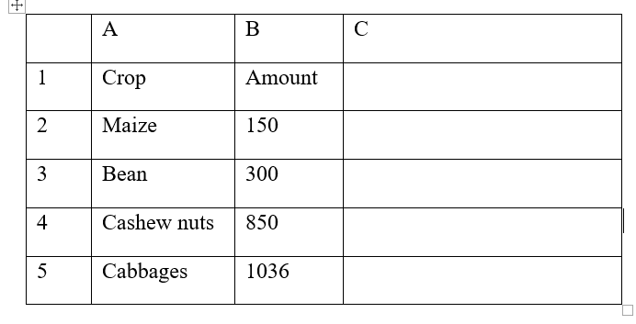

(i) A function = IF(B2<200,”Poor Yield”, IF(B2>300, “Moderate”, IF(B2>1000,”Great Yield”))).
Give the appropriate result returned in cells C2, C3, C4, and C5 (2mks)
…………………………………………………………………………………………………………
…………………………………………………………………………………………………………
…………………………………………………………………………………………………………
…………………………………………………………………………………………………………

  - A computer user may interact with a computer either through Graphical User Interface (GUI) or though typed commands
    - Give one advantage of using GUI based operating system over a command line interface ( 1 mk)
…………………………………………………………………………………………………………
…………………………………………………………………………………………………………

(b) Some computer systems still use command line interfaces. State two advantages of command line interface (2mks)
…………………………………………………………………………………………………………
…………………………………………………………………………………………………………
…………………………………………………………………………………………………………
…………………………………………………………………………………………………………
  - (a) Distinguish between data verification and data validation as used in data processing(2mks)
…………………………………………………………………………………………………………
…………………………………………………………………………………………………………
…………………………………………………………………………………………………………
…………………………………………………………………………………………………………

(b) List any two file organization methods (1 mk)
…………………………………………………………………………………………………………
…………………………………………………………………………………………………………

SECTION B (40 MKS)
Answer question 16 and any other THREE questions
  - a) Study the following flowchart and answer the questions that follow
Start
Sum = 0
R = 0
R = R + 1
Term = R*(2)^2
Sum = Sum +Term
R=3?
Print sum
Stop

No

Yes

- Dry run the above flowchart clearly showing how the output will be arrived at (4mks)

- Convert the above flowchart into a pseudocode (6mks)

b) Explain three types of documentations that a programmer needs to prepare (3mks)
…………………………………………………………………………………………………………
…………………………………………………………………………………………………………
…………………………………………………………………………………………………………
…………………………………………………………………………………………………………
…………………………………………………………………………………………………………
c) State two differences between a compiler and an interpreter (2mks)
…………………………………………………………………………………………………………
…………………………………………………………………………………………………………
…………………………………………………………………………………………………………

  - a) Define data integrity (1mk)
…………………………………………………………………………………………………………
…………………………………………………………………………………………………………
b) Explain any four threats to data integrity in computer systems (4mks)
…………………………………………………………………………………………………………
…………………………………………………………………………………………………………
…………………………………………………………………………………………………………
…………………………………………………………………………………………………………
…………………………………………………………………………………………………………
…………………………………………………………………………………………………………
c) Giving examples differentiate between transposition and misreading errors (3mks)
…………………………………………………………………………………………………………
…………………………………………………………………………………………………………
…………………………………………………………………………………………………………

d) The following records were extracted from two files contained in a students’ database
File A
Registration Number Student name Gender Address
3001 Tom Onyancha M 4646 Kisii
3002 Amina Amima F 4322 Garissa
3003 Jane Anita F 2333 Nairobi
3004 Jack Kalweo M 3822 Meru

File B
Registration Number Fees Paid Date of Payment
3001 12,090 04/01/2020
3002 11,000 06/02/2020
3003 12,000 07/01/2020
3004 15,000 08/01/2020

i) Which of the two files above represents a transaction file ? (1mk)
…………………………………………………………………………………………………………
…………………………………………………………………………………………………………

ii) Give reason for your answer in17 a) i) above (2mks)
…………………………………………………………………………………………………………
…………………………………………………………………………………………………………
…………………………………………………………………………………………………………

- Name the other type of file represented above (1mk)
…………………………………………………………………………………………………………
…………………………………………………………………………………………………………

- Identify the most appropriate primary field from the above data (1mk)
…………………………………………………………………………………………………………
…………………………………………………………………………………………………………

e) Differentiate between multiprocessing and multitasking systems (2mks)
…………………………………………………………………………………………………………
…………………………………………………………………………………………………………
…………………………………………………………………………………………………………
…………………………………………………………………………………………………………

  - a) State three advantages of using a laptop over desktop computer (3mks)
…………………………………………………………………………………………………………
…………………………………………………………………………………………………………
…………………………………………………………………………………………………………
…………………………………………………………………………………………………………

b) Explain three ways computers would be made more friendly to people with physical disabilities like the blind and handicapped (3mks)
…………………………………………………………………………………………………………
…………………………………………………………………………………………………………
…………………………………………………………………………………………………………
…………………………………………………………………………………………………………
…………………………………………………………………………………………………………
…………………………………………………………………………………………………………

18 (c) I. Differentiate between system review and system maintenance. (4 mks)
…………………………………………………………………………………………………………
…………………………………………………………………………………………………………
…………………………………………………………………………………………………………
…………………………………………………………………………………………………………
…………………………………………………………………………………………………………

II. Mention THREE characteristics of a good interface design (3 mks)
…………………………………………………………………………………………………………
…………………………………………………………………………………………………………
…………………………………………………………………………………………………………
…………………………………………………………………………………………………………

  - a. Rehema school electoral system clerk stores the results of elections in folders. The school has two streams (W and S) each in form one, form two, form three and form four. The student administrative structure is in three levels, school level, form level and class level. The school level student leadership positions comprise of the head boy, the head girl, dining hall captain, games captain and the library captain. The form level positions comprise form captains who are in charge of all the streams in their respective forms. The class level positions comprise of the class prefects who are in charge of their respective classes. A folder labeled 2020 is stored in a root directory C hold these information. Draw a tree directory to represent the information above. (6 mks)

b. What do you understand by the following terms as used in Operating Systems? (4 mks)
i) Deadlock……………………………………………………………………………………………
…………………………………………………………………………………………………………
ii) Interrupt……………………………………………………………………………………………
…………………………………………………………………………………………………………

c. i) Fill in the blank spaces with the most appropriate answers of the open systems interconnection (OSI) reference model layers. (3mks)
Layer no. | Layer | Function
7 | Application layer | User applications run here and generate request for data transmission or open received information
1 |  | The data packets are finally transmitted via the network card through the transmission media in form of bits
4 | Transport layer
6 |  | Adds formatting, display and encryption information to the data being sent.

ii) Differentiate between baseband and broadband transmissions. (2 mks)
…………………………………………………………………………………………………………
…………………………………………………………………………………………………………
…………………………………………………………………………………………………………
…………………………………………………………………………………………………………

  - a) i. List THREE possible threats to data in a network (3 mks)
…………………………………………………………………………………………………………
…………………………………………………………………………………………………………
…………………………………………………………………………………………………………
…………………………………………………………………………………………………………

ii. State THREE control measures that can be taken to mitigate the threats above (3 mks)
…………………………………………………………………………………………………………
…………………………………………………………………………………………………………
…………………………………………………………………………………………………………
…………………………………………………………………………………………………………

b) Explain THREE uses of information systems in an organization (6 mks)
…………………………………………………………………………………………………………
…………………………………………………………………………………………………………
…………………………………………………………………………………………………………
…………………………………………………………………………………………………………
…………………………………………………………………………………………………………
…………………………………………………………………………………………………………
…………………………………………………………………………………………………………
…………………………………………………………………………………………………………

c) Give THREE types of data that can be used to test a developed system (3 mks)
…………………………………………………………………………………………………………
…………………………………………………………………………………………………………
…………………………………………………………………………………………………………
…………………………………………………………………………………………………………

*this is the last printed page*

